Disability Equality Scotland
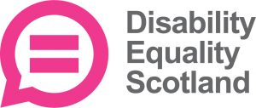

Inclusive Communication Hub Survey 2021

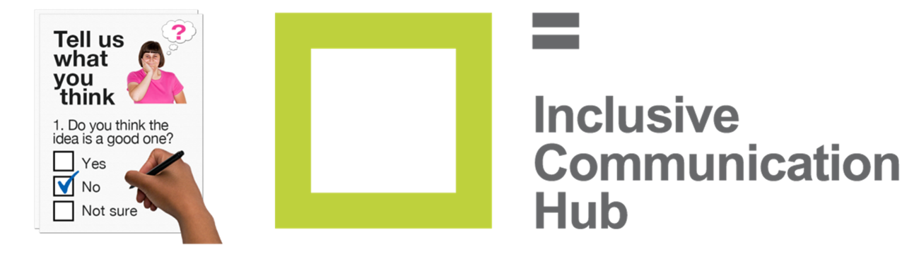

Easy Read

Copyright images © Photosymbols. Prepared by Disability Equality Scotland

 | Inclusive Communication means sharing information in a way that everyone can understand.
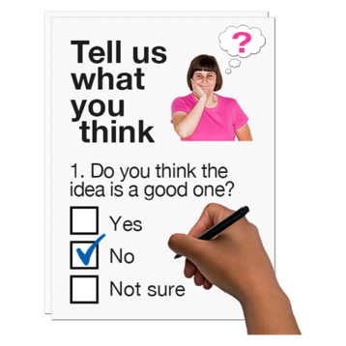 | In this survey we ask you about:  - your understanding of Inclusive Communication  - our Inclusive Communication Hub website  www.inclusivecommunication.scot
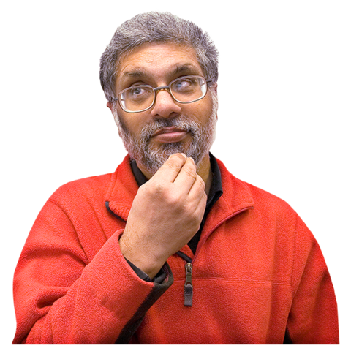 | Knowing about Inclusive Communication
1. Do you know about Inclusive Communication?

Tick 1 box.

Yes, a lot

Yes, a little

No, not at all

2. Do you think that:
- public organisations
- private organisations
- third sector organisations
need to get better at Inclusive Communication?
Tick 1 box.
Yes

No

I don’t

know

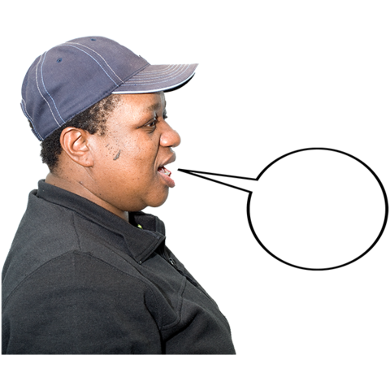 | Please tell us about your experiences with Inclusive Communication. The space will grow as you type.
3. Have you been given information about the COVID-19 pandemic in a way that you can understand?

Tick 1 box.

Yes

No

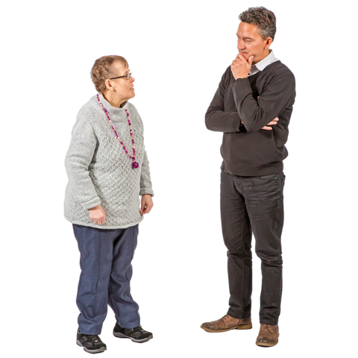 | Please tell us about your experiences with COVID-19 information. Write or type it here.
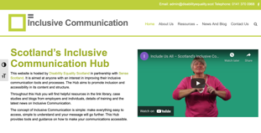  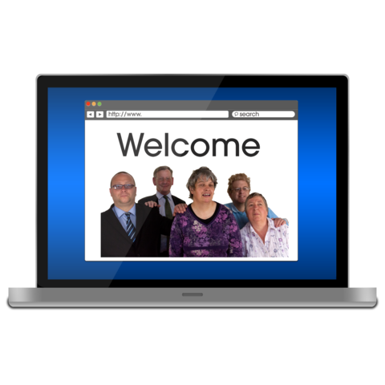 | Please click the blue words to go to our website www.inclusivecommunication.scot  Have a look around the website and then answer question 4.  The website is all about Inclusive Communication.  It has information and resources.  It helps people understand how to make sure no-one is left out of shared information.
The website is made by:
- Disability Equality Scotland
- Sense Scotland
It’s the place where all information about Inclusive Communication is kept.
Organisations can use it to make their communication better.

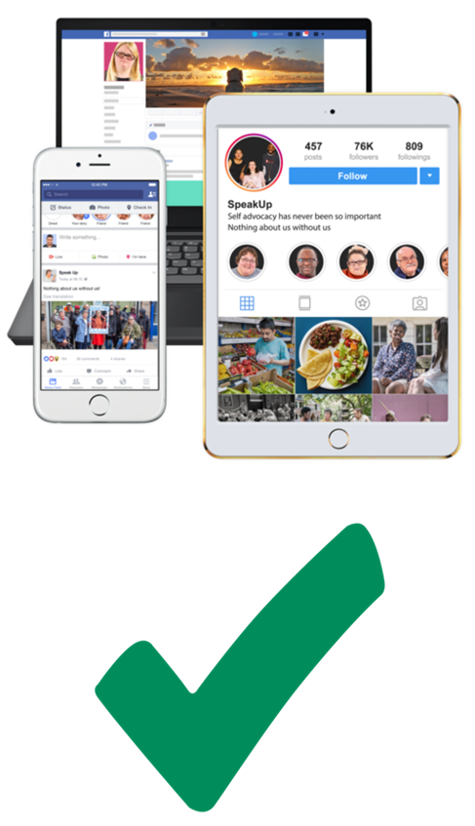 | 4. What device did you use to look at the Inclusive Communication Hub website?  Tick 1 box.  A computer or laptop  A smartphone or tablet
5. How easy was it to move around the website?
Tick 1 box.
Very easy

Quite easy

Not easy at all

6. How much do you trust the information on the website?

Tick 1 box.

I trust it a lot.

I trust it a little.

I don’t trust it at all.

 | 7. How useful is the information on the Inclusive Communication Hub website?
Tick 1 box.

very useful

quite useful

not useful

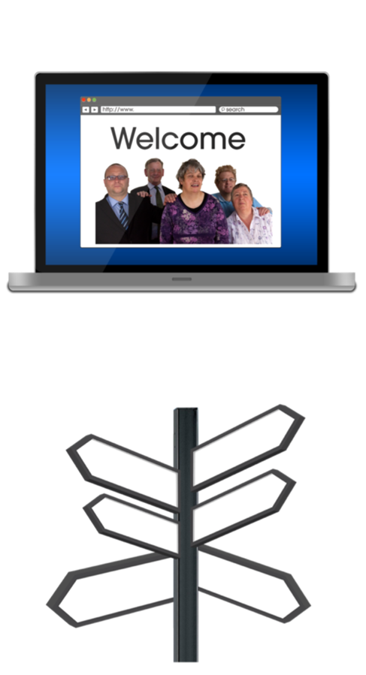 | 8. On our website we have a resources library. It points you to information from organisations in Scotland in 9 different groups.  These 9 groups are:  - Arts, Culture and Sport  - Children and Families  - Crime, Justice and Public Safety  - Education and Training  - Employment  - Health and Social Care  - Housing and the Built Environment  - Information and Technology  - Transport and Travel  Do you think these 9 groups cover everything?
Tick 1 box.

Yes

No

 | If you ticked No, please tell us what is missing.
9. What kind of things would you like to see added to the Inclusive Communication Hub?
Tick as many boxes as you want.

Guidance about Inclusive Communication
Good examples of Inclusive Communication. These are called case studies.

Events

Training

Something else
Please tell us what here:

10. Would the website be better if people could say how helpful the information was?
This could be 1 star for bad information and 5 stars for great information.

Tick 1 box.

Yes

No

I don’t know
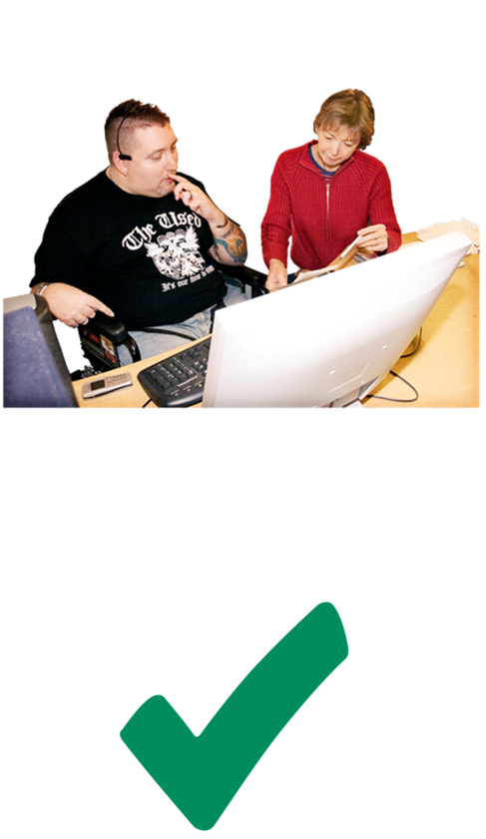 | 11. Do you know if there are other websites and resources which are also about Inclusive Communication?  Tick 1 box.  Yes  No  If you ticked Yes, please tell us what it’s called, here:
12. Would you tell your friends or colleagues about our website?

Tick 1 box.

Yes I would

I might

No I wouldn’t

13. Do you have any more comments about how:
- easy to use
- useful
the website is?
Please write or type them here. The space will grow as you type.

Getting involved
14. Would you like to share:
- your experiences
- guidance
- resources

and help add to our website?
Tick 1 box.

Yes

No

 | If you ticked Yes, please fill in the next parts too.
 | My name:
 | My email address:
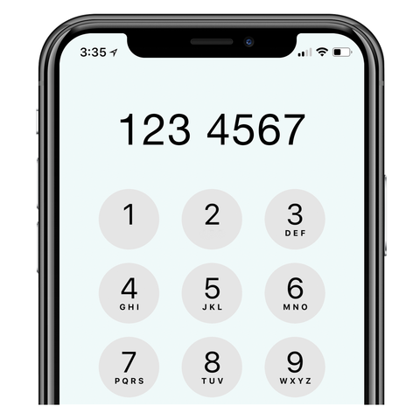 | My phone number:
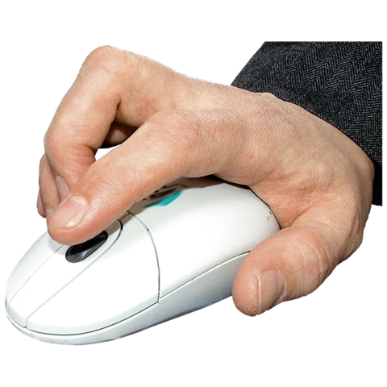 | Please send your answers back to james.davidson@disabilityequality.scot  If you need to let us know anything more, please email Alistair at the same address above.  Thank you for answering this year’s Inclusive Communication Hub Survey.

